**Dashboard Design**

|  |  |
| --- | --- |
| Date | 20 march 2025 |
| Team ID | LTVIP2025TMID26725 |
| Project Name | Visualization Tool for Electric Vehicle Charge and Range Analysis |
| Maximum Marks | 5 Marks |

Creating an effective dashboard involves thoughtful design to ensure that the presented information is clear, relevant, and easily understandable for the intended audience. Here are some key principles and best practices for dashboard design

**Activity 1: Interactive and visually appealing dashboards**

**Dashboard Overview :**

This dashboard presents key insights into electric vehicle (EV) brands, efficiency, powertrain types, top speeds, and pricing in India. It includes bar charts, bubble charts, pie charts, and interactive filters to enhance user engagement.

**Key Insights and Visualizations**

* **Top 10 Most Efficient EV Brands**
* A bar chart compares efficiency (Wh/km) across different brands.
* Brands such as Tesla and Volkswagen show the highest efficiency.
* **EV Brand Summary**
* A bubble chart provides an overview of different brands of EVs in India.
* **Top Speed for Different Cars in India**
* A bar chart highlights the highest speed of various EV models.
* Audi leads with a top speed of 3178 km/h (potential data error).
* **Number of Models by Each Brand**
* A bubble chart visually represents the variety of models available**.**
* **Brand Filtered by Power Train Type**
* A pie chart shows the distribution:
* AWD (All-Wheel Drive): 50.11%
* FWD (Front-Wheel Drive): 28.44%
* RWD (Rear-Wheel Drive): 21.45%
* **Different EV Cars in India**
* A horizontal bar chart maps EV models against their price range in lakhs.
* The Sport back 55 model is one of the premium options.

**Interactive Features**

* **Clickable Buttons (e.g., "CLICK HERE," "TOUCH ME")**
* Enhance user experience with navigation shortcuts**.**
* **Filters & Drill-Downs**
* Users can explore brands by efficiency, price, and powertrain type**.**

**Let me know if you need modifications or a structured table representation.**

Creating interactive and visually appealing dashboards involves a combination of thoughtful design, effective use of visual elements, and the incorporation of interactive features. Here are some tips to help you design dashboards that are both visually appealing and engaging for users so take care of below points

**Design Considerations Applied**

* **Clear and Intuitive Layout** – Charts are organized for easy readability.
* **Appropriate** **Visualizations** – A mix of bar, pie, and bubble charts.
* **Color & Theming** – Different colors for each data type enhance clarity.
* **Interactive Features** – Clickable elements improve engagement**.**

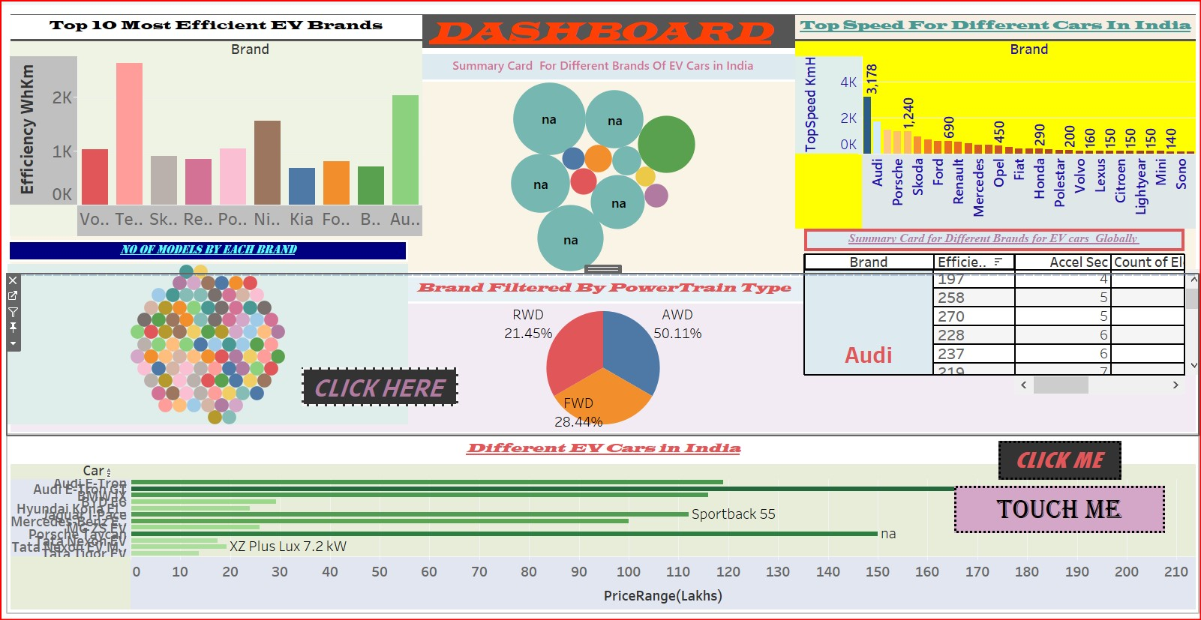

**Here are five potential outcomes based on the dashboard image:**

**Identification of Top Efficient EV Brands –** The bar chart in the top left shows the efficiency of different EV brands in WH/km, allowing users to compare which brands offer the most energy-efficient vehicles.

**Analysis of Car Speed Performance –** The yellow bar chart on the top right presents the top speed of different EV brands in India, highlighting which brands offer the fastest electric vehicles.

**Breakdown of Powertrain Types –** The pie chart in the middle provides insights into the distribution of drivetrain types (AWD, FWD, RWD) among different EV brands, helping buyers understand common drivetrain preferences.

**Comparison of EV Car Prices in India –** The green bar chart at the bottom visualizes different EV models available in India along with their price ranges in lakhs, assisting potential buyers in budget-based decision-making.

**Model Availability Across Brands –** The bubble chart labeled "No of Models by Each Brand" illustrates how many EV models each brand has in the market, giving an overview of brand diversity and choices available.